1. What is the Nernst (equilibrium) potential of a monovalent cation (+ valence) at 37oC given the intracellular ion concentration is 10 mM and the extracellular ion concentration is 80 mM?

Temperature, $T=37 ⇒310.15K$

Gas constant, $R=2$

Faraday’s constant, $F=2.3×{10}^{4}$

Charge of the ion, $z=+1$

Intracellular ion concentration, $C_{i}=10$

Extracellular ion concentration, $C_{o}=80$

Nerst potential, $V=\frac{RT}{zF}\ln{\frac{C_{o}}{C_{i}}}=\frac{2×310.15}{2.3×{10}^{4}}\ln{\frac{80}{10}}=5.6×{10}^{-4}V$

Review: Correct.

1. What is the resting membrane potential at 37 oC with relative permeability’s of PNa = 3, PK = 33 given the table below?

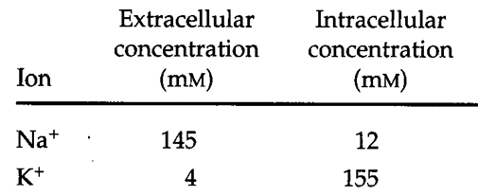

$$V=\frac{RT}{zF}\ln{\frac{C_{o}}{C_{i}}}=\frac{2×310.15}{2.3×{10}^{4}}\ln{\frac{\left(33×4\right)+\left(3×145\right)}{\left(33×155\right)+\left(3×12\right)}}=-5.95×{10}^{-4}V$$

Review: Correct

1. The two voltage wavefroms associated with the electroneurogram in Figure P3A differ in shape and size. The change in voltage shape with distance can be thought of as a low pass filter process, where a given distance along the nerve corresponds to one passage through a low pass filter, as shown in Figure P3B.

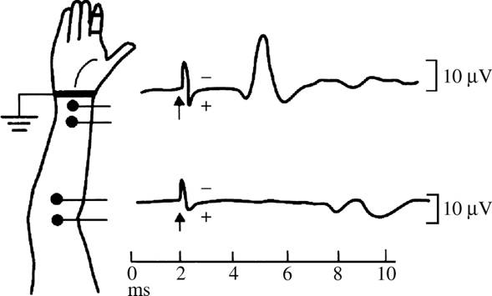

**Figure P3A.**

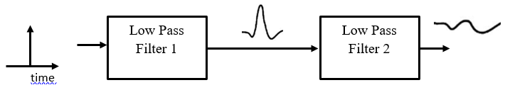

**Figure P3B**

1. If the initial stimulus is modeled as a delta function in time,

$$δ\left(t\right)=\left\{\begin{matrix}0 \text{if} t≠0 \\ ∞ \text{if} t=0\end{matrix}\right.$$

and if Filter 1 has a “boxcar” shape in frequency

$$H\left(jω\right)=\left\{\begin{matrix}1 \text{if} \left|\frac{ω}{2π}\right|≥1000 \text{Hz} \\ 0 \text{if} \left|\frac{ω}{2π}\right|>1000 \text{Hz}\end{matrix}\right.$$

what is a mathematical form for the output of the first filter? (Hint: You will need to review filter impulse responses from BIEN 225.)

Review:

$$v\left(t\right)=\frac{1}{2π }\int_{-∞}^{∞}{H\left(jω\right)e^{jωt}\text{dw}}$$

$$v\left(t\right)=\frac{1}{2π }\int_{-ω_{0}}^{ω_{0}}{e^{jωt}\text{dw}}$$

$$v\left(t\right)=\frac{1}{2π }\left(\frac{e^{ω_{0}t}}{jt }-\frac{e^{-ω_{0}t}}{jt }\right)=\frac{1}{2π } sin\left(ω_{0}t\right)=\frac{ω_{0}}{π } sin\left(ω_{0}t\right)$$

1. Plot the output of the first filter as a function of time.

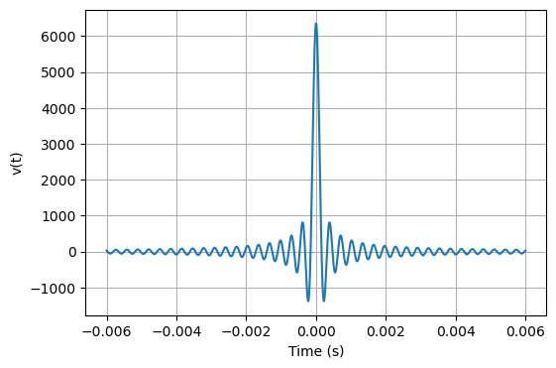

1. If the second filter has a shape $H\left(jω\right)$ and the input to this filter is $v(t)$, what is the mathematical relationship that you would need to evaluate to find the filter’s output?

**Review:**

The time waveform $v\left(t\right)$ and transfer function of the second filter $H_{2}\left(jω\right)$. To get the time waveform $v_{2}\left(t\right)$, we need to multiply the Fourier transform of $v\left(t\right)$ by $H_{2}\left(jω\right)$ and take the inverse Fourier transform.

$$v_{2}\left(t\right) = \frac{1}{2π} \int_{-∞}^{∞}{V_{2}\left(ω\right)} e^{ jω t} dω$$

Substitute $\int_{-∞}^{∞}{V_{2}\left(ω\right)}=V\left(ω\right)H_{2}\left(jω\right)$ into that integral:

$$v_{2}\left(t\right) = \frac{1}{2π} \int_{-∞}^{∞}{ }\left[\int_{-∞}^{∞}{v\left(τ\right)} e^{-j ω τ} \text{dt}\right] H_{2}\left(jω\right) e^{jω t} d$$

**Graduate Content**

FFT and Fourier Series

I. In Matlab perform the following:

t=[0:1:200]; % Time in seconds

wt=2.*pi*0.005*t; % base frequency is 0.005 Hz

z=1 + cos(10*wt) + 0.5.*cos(20.*wt) + 0.25.*cos(30.*wt) + 0.125.*cos(40.*wt);

figure(1);

plot(wt,z);

b=fft(z);

c=b.*conj(b);

figure(2);

plot(c);

Answer the following questions:

1. What is the meaning of the variable “wt.” Why is it an appropriate variable to use in this program?

**Review**: wt is omega times t or frequency times t. Using the variable eliminates repetitive multiplication.;

1. What is the time average of the signal z?

**Review**: The DC component $\overline{z}=1$

1. What does the line b=fft(z) do?

**Review**: fft(z) takes the Fourier transform of z.

1. Why is it necessary to take abs(b)?

**Review**: since b is a complex array, it needs to converted to a real variable to plot.

1. What is the x-axis in the plot of c?

**Review**: the x-axis is the default axis.

1. The plot of c looks like a series of delta functions. Why?

**Review**: the power spectrum of a sum of cosines is a series of delta functions at the cosine frequencies.

1. What is the true frequency that corresponds to the x-axis value of 200 on the plot?

**Review**: $-Δf$, where $Δf$ is $1/T$ and T is the total time of the signal.

1. What is the true frequency that corresponds to the x-axis value of 180 on the plot?

**Review**: $-21Δf$

1. Find the component that corresponds to the third term in the expression for z. What is the value of the peak of this component on the plot?

**Review**: $0.5\cos\left(20ωt\right)$, which occurs at 0.1/0.005.

1. Why is the value of the peak of the third term peak not equal to $0.5×0.5$?

**Review**: 0.125

2. Now run the following Matlab code:

a=[0:1:400];

wt=2.*3.14159.*a/200;

z1=1 + cos(10*wt)+ 0.5.*cos(20.*wt) + 0.25.*cos(30.*wt) + 0.125.*cos(40.*wt);

z2 = 1+zeros(1,401);

a2 = [0:1:801];

wt2=2*3.14159*a2/400;

h1 = figure(1);

z = [z1 z2];

plot(wt2,z);

b=fft(z);

c=b.*conj(b);

h2 = figure(2);

plot(c);

1. At what x-axis value is the peak corresponding to the third term of z1 (i.e. $0.25\cos{(20ωt)}$) located?

**Review**: $x=80$

1. Explain why the value is not the same as the value obtained with the first set of code.

**Review**: the input data were zero padded, so the time duration of the signal is twice as long and $Δf$ half as large.

1. What is the peak value of the peak corresponding to the third term of z1?

**Review**: 200

1. Explain why the peak value is not the same as it was with the first set of code.

Review: the power spectrum needs to include $Δf$ in the normalization.

1. Zoom in on the first non-DC peak (corresponding to cos(10*wt)) and describe its shape.

Review: it has a central peak with multiple side lobes.

1. Explain why this peak has the shape that it does.

Review: the signal has been windowed with a rectangle of duration T/2. The spectrum is the convolution of the signal spectrum with the window spectrum. The window spectrum is the sinc function.

1. Find a mathematical expression that describes the spacing (in frequency) between the secondary peaks around the peak.

Review: the difference between the peaks is:

$$Δω=\frac{2π}{T}{(n}_{k}-n_{k-1})$$

1. Find a mathematical expression for the peak values of the secondary peaks.

Review:

With sin portion as 1, $f(ω_k = 2/(πω_k)$

1. Print out the plots of (wt,z) and the plot of c, and turn these in with the answers to the above questions.

Review:

Plots for the first section.

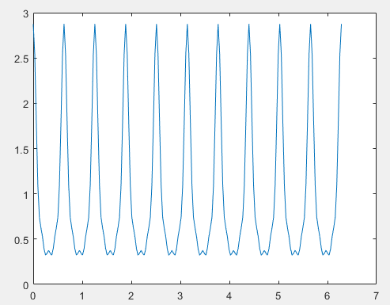 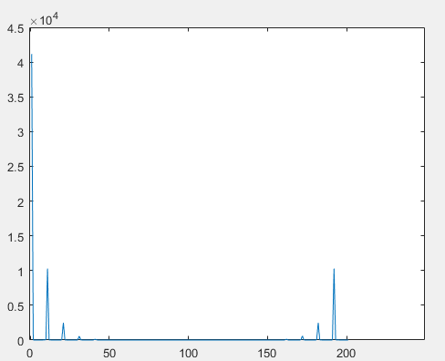

Plots for the second section.

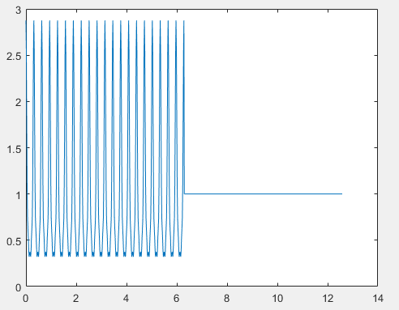 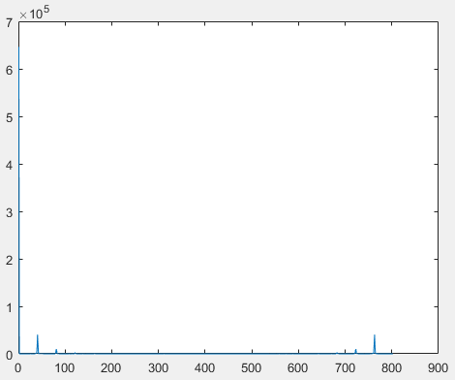

II. Use the Fourier series that represents a square wave, and write a program that **computes** and **plots** the first n terms of this expansion (where n is a variable that you will input when you call the function). You should be able to call this routine with the line:

>> squarewave(n);

**Review**:

function squaresig = squarewave(n)

npts = 1000.;

totaltime = 1.0; %seconds

dt = totaltime/npts;

t = 0:dt:totaltime-dt;

f = 1.0/totaltime;

wt = 2*pi*f*t;

a0 = 2/pi;

squaresig = zeros(1,npts);

for k = 1:2:n

a = a0/k;

squaresig = squaresig + a*sin(k*wt);

end

plot(t,squaresig);

end

With this routine, calculate and plot the n-term Fourier expansion of the square wave for n=1, n=2, n=10, n=100, and n=1000.

Turn in the plots for these five cases.

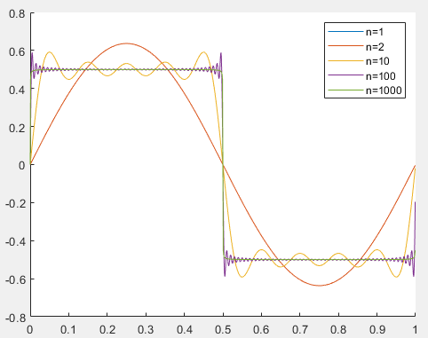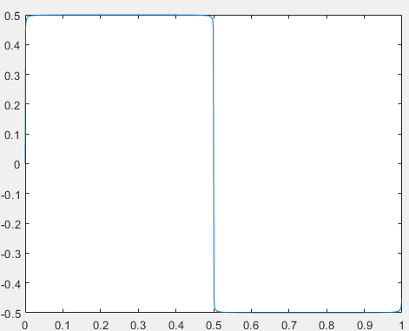

How many terms are needed to obtain a reasonable approximation of the square wave.

n=1000

III. Modify the program you wrote in II above to calculate a triangle wave instead of a square wave.

**Review**:

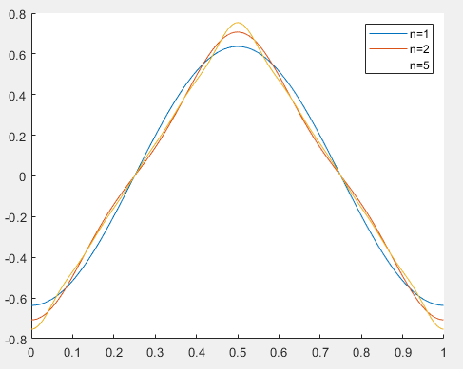

1. Now how many terms are required to obtain a reasonable approximation of the triangle wave?

**Review**: With as small as n=5, we can have a decent triangle wave.

1. Why is this number so much smaller than the number of terms required for the square wave?

Review: square waves contain vertical lines, that requires infinite slope to approximate. Since sine wave doesn’t have infinite derivative, square wave can’t be approximated without infinite terms.

**Comment:** *I didn’t have a background in signal processing (or biomedical engineering or electrical engineering in general), so I didn’t know how to approach the graduate-level material.*